FGA = field goal attempts, FGM = FG’s made
3PA = 3-point attempts, 3PM = 3-pointers made

Opponent: _____________________ Where: ________________ Date: _______________
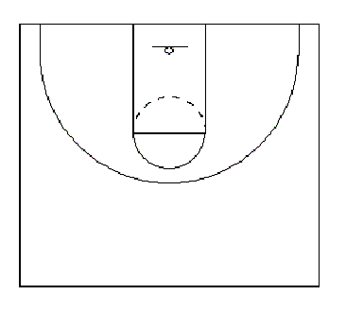
FGA: ________ FGM: __________ FGA: ________ FGM: __________

3PA: ________ 3PM: __________ 3PA: ________ 3PM: __________

1st Half
FGA: ______ FGM: ________ %: ________ 3PA: ________ 3PM: ________ %: ________

Quarter #3 Quarter #4
Quarter #1 Quarter #2

FGA: ________ FGM: __________ FGA: ________ FGM: __________

3PA: ________ 3PM: __________ 3PA: ________ 3PM: __________

Totals

FGA: ______ FGM: ________ %: ________ 3PA: ________ 3PM: ________ %: ________

